Implementing DVB-SIS

MAINDATA

**1 Scope** **7**

**2 System Overview and Architecture** **7**

**3 Specification of Parent Signals** **9**

3.1 Overview 9

3.2 Service Information (PSI/SI) 10

3.2-1 SIS Services carrying PCRabs 12

3.3 Service Information description² 12

3.4 Service Information tables 12

3.4-1 Service information table mechanism 12

3.4-1-1 Use of table sections 12

3.4-2 Mapping of sections into DVB transport stream packets 12

3.4-3 Coding of PID and table_id fields 12

3.4-4 Repetition rates and random access 12

3.4-5 Scrambling 12

3.4-6 Bit order and transmission order 12

3.5 Table definitions 12

3.5-1 Introduction 12

3.5-2 Network Information Table 12

3.5-3 Bouquet Association Table 12

3.5-4 Service Description Table 12

3.5-5 Event Information Table 12

3.5-6 Time and Date Table 12

3.5-7 Time Offset Table 12

3.5-8 Running Status Table 12

3.5-9 Stuffing Table 13

3.5-10 Discontinuity Table 13

3.5-11 Selection Information Table 13

3.6 Descriptors 13

3.6-1 Introduction 13

3.6-1-1 Descriptor identification and location 13

3.6-2 Descriptor coding 13

3.6-2-1 General principles 13

3.6-2-2 Adaptation field data descriptor 13

3.6-2-3 ancillary data descriptor 13

3.6-2-4 Announcement support descriptor 13

3.6-2-5 Bouquet name descriptor 13

3.6-2-6 CA identifier descriptor 13

3.6-2-7 Cell frequency link descriptor 13

3.6-2-8 Cell list descriptor 13

3.6-2-9 Component descriptor 13

3.6-2-10 Content descriptor 13

3.6-2-11 Country availability descriptor 13

3.6-2-12 Data broadcast descriptor 13

3.6-2-13 Data broadcast descriptor 13

3.6-2-14 Delivery system descriptors 13

3.6-2-14-1 Cable delivery system descriptor 14

3.6-2-14-2 Satellite delivery system descriptor 14

3.6-2-14-3 S2 satellite delivery system descriptor 14

3.6-2-14-4 Terrestrial delivery system descriptor 14

3.6-2-15 DSNG descriptor 14

3.6-2-16 Extended descriptor 14

3.6-2-17 Extension descriptor 14

3.6-2-18 Frequency list descriptor 14

3.6-2-19 FTA content management descriptor 14

3.6-2-19-1 Semantics and syntax of the linkage descriptor 14

3.6-2-19-2 Scope of the FTA content management descriptor 14

3.6-2-20 Linkage descriptor 14

3.6-2-20-1 Semantics Linkage descriptor 14

3.6-2-20-1 Linkage descriptor 14

3.6-2-20-1 Linkage descriptor 14

3.6-2-20-1 Linkage descriptor 14

3.6-2-21 Local time offset descriptor 14

3.6-2-22 14

3.6-2-23 14

3.6-3 Extended descriptor identification and location 14

3.6-4 Extended descriptor coding 14

3.6-4-1 General principles 14

3.6-4-7 Delivery system descriptors 15

3.6-4-7-1 C2 delivery system descriptor 15

3.6-4-7-2 C2 delivery system descriptor 15

3.6-4-7-3 C2 delivery system descriptor 15

3.6-4-7-4 C2 delivery system descriptor 15

3.6-4-7-5 C2 delivery system descriptor 15

3.6-4-8 Image icon descriptor 15

3.6-4-17 Video depth range descriptor 15

3.6-4-17-1 15

3.6-4-17-2 15

3.6-5 Scoping rules for scoping descriptors 15

3.7 Storage Media Interoperability measures 15

3.7-1 Introduction 15

3.7-2 15

3.7-3 15

3.7-3-1 General principles 15

3.7-3-2 General principles 15

3.7-3-3 General principles 15

3.7-4 SMI descriptors 15

3.7-4-1 Introduction 15

3.7-4-2 Partial transport stream descriptor 15

**4 Control Signal/Stream Generator (CSG)** **17**

4.1 Layer 1 Signaling: 17

4.1-1 DVB-T2 case 17

4.1-2 DVB-T case 17

4.2 Other T2-MI packet types (DVB-T2 case) 18

4.3 Framing & Timing Information (F&TI) 18

4.3-2 Overview 18

4.3-3 DVB-T2 case 18

4.3-4 DVB-T case 18

4.4 DSA Configuration Information (DSACI) 18

4.4-1 Overview 18

4.4-2 DSACI Structure 18

4.4-2-1 XML schema representation 18

4.4-3 XML types and XML elements of the DSA Configuration Information 18

4.4-3-1 Global Configuration¤ 18

4.4-3-1-1 Overview 18

4.4-3-2 Input Configuration 18

4.4-3-2-1 Overview 18

4.4-3-3 Remultiplexing 18

4.4-3-4 PID processing 18

4.4-3-5 Service and PMT processing 18

4.4-3-6 PSI/SI 18

4.4-3-7 PAT processing 18

4.4-3-8 CAT processing 18

4.4-3-9 SDT and BAT processing 19

4.4-3-10 EIT processing 19

4.4-3-11 Output configuration 19

**5 Daughter Site Adapter (DSA)** **21**

5.1 Overview (DVB-T2 and-T cases) 21

5.2 Bootstrapping 21

5.2-1 Overview 21

5.2-2 Gaining access to DSACI provided in-band 21

5.2-3 Out-of-band DSACI provision 21

5.3 Input processing 21

5.3-1 Reception of parent Transport Streams 21

5.3-1-1 Overview 21

5.3-1-2 Arrival timestamping 21

5.3-1-3 Calculation of Virtual Arrival Timestamp (VATs) 21

5.3-1-3-1 Overview 21

5.3-1-3-2 CBR operation mode 21

5.4 TS re-multiplexing 22

5.4-1 Overview 22

5.4-2 Generation of Reference Transport Streams 22

5.4-2-1 Overview 22

5.4-2-2 DVB-T2 case 22

5.4-2-3 DVB-T case 22

5.4-2-3-1 Overview 22

5.4-2-2-1 Extraction of F&TI packets 22

5.4-3 Selection of relevant content from input TSs 22

5.4-4 Processing and generation of Layer 2 signaling (PSI/SI) 22

5.4-4-1 Background 22

5.4-4-2 Pass-through remultiplexing of selected parent tables/sections 22

5.4-4-3 Conversion of parent table/sections on the fly (patching) 22

5.4-4-4 Static table regeneration 22

5.4-4-4-1 Overview 22

5.4-4-4-2 SDT and BAT regeneration 22

5.4-4-5 Dynamic table regeneration 22

5.4-4-5-1 Overview 22

5.4-4-5-2 Phase (A): Creation of a list of EIT_slots 22

5.4-4-5-3 Phase (B): Creation of the EIT_sections database 22

5.4-4-5-4 Phase (C): Creation of the EIT_slot list 22

5.4-4-5-5 Parameter definition 22

5.4-5 Placement of incoming packets in the outgoing TS 23

5.4-5-1 Overview 23

5.4-5-2 Deterministic scheduling 23

5.5 Framing 23

5.5-1 DVB-T2 case 23

5.5-1-1 TS splitting (optional) 23

5.5-1-2 Partial Mode Adaptation 23

5.5-1-3 Allocation of TS bits to Interleaving Frames 23

5.5-1-4 Null Packet Deletion 23

5.5-1-5 ISSY generation 23

5.5-1-6 Generation of BBFRAMEs 23

5.5-1-6-1 Overview 23

5.5-1-6-2 Allocation of bits to BBFRAMEs of the interleaving Frame 23

5.5-1-6-3 Mapping of mode-adapted bit into the BBFRAMES 23

5.5-1-6-4 BBHEADER generation 23

5.5-2 DVB-T case 23

5.6 Extraction of T2-MI packets 24

5.7 Output processing 24

5.7-1 DVB-T2 case 24

5.7-1-1 T2-MI multiplexing 24

5.7-1-2 Transport of T2-MI packets in MPEG-TS 24

# 1 Scope

This document describes the Single Illumination System, which allows to deliver Parent Signals for direct reception by consumers receivers and, at the same time, for a deterministic generation of daughter streams for terrestrial retransmission.

Parent Signals can be provided to the daughter site via all defined TS-based DVB means - be it satellite, cable or terrestrial.

Metadata may be provided as part of the Parent Signal(s) (called in-band). Part of the metadata may also be provided out-of-band.

A typical use case is described and is based on satellite broadcast signals on the parent side - be it DVB-S -S2 or -SX signals - that are addressing consumer Direct-to-Home (DTH) receivers and terrestrial transmitters on the daughter side in parallel. For terrestrial retransmission of the whole or partial content, the DTH signal(s) of MPEG-2 TS format from one or several satellites can be used and services and service components can be selected according to terrestrial broadcasters’ needs. Also other non-satellite Parent Signals and out-of-band metadata feeds can be integrated into the preparation of the terrestrial DVB-T2, and/or DVB-T signals on the daughter site. Single Frequency Networks (SFN) operation of the terrestrial networks driven by the Single Illumination System is enabled.

# 2 System Overview and Architecture

The target is. On the one hand, it is to feed receivers installed at consumer’s households with (a) Parent Signal(s) suitable for direct reception and, on the other hand, to use the same signal(s) to derive services and service components for terrestrial retransmission. The Parent Signal(s) might typically be uplinked - via DVB-S, -S2, or -SX - to (a) satellite(s). The terrestrial multiplexes could be either by DVB-T2 or DVB-T multiplexes and shall be suitable for use in SFN networks.

Central functional blocks on the parent site are the Control Stream Generator (CSG) and the Transport Stream multiplexer that prepares the TS that is transmitted to consumers. The CSG prepares all metadata that is not Layer 2 (PSI/SI), i.e., the Layer 1 signaling, the Framing & Timing (F&TI) as well as the DSA Configuration Information (DSACI).

The CSG obtains instructions from its control interface (man-machine interface, etc.) for the configuration of the DVB-T2 and/or DVB-T transmission frames that its counterpart of the daughter site, the Daughter Site Adapter (DSA), will eventually build. On that basis it generates the required metadata. On the Daughter side the DSA receives Parent Signal(s) from one or more DVB networks and extracts services and service components for terrestrial retransmission. That selection is determined by the DSA Configuration Information (DSACI). The latter also provides instructions to the DSA for the preparation of the terrestrial PSI/SI. In the T2 case, Layer 1 signaling is only decapsulated and inserted into the output T2-MI stream. Framing & Timing Information indicates frame boundaries - in the T2 case the boundaries between interleaving frames and in the T case the boundaries between T mega-frames. The latter signals are output by the DSA to the related modulator(s).

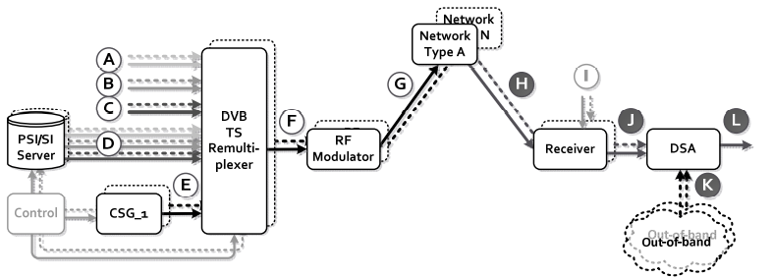

Figure 2a: Conceptual block diagram of the Single Illumination transmission chain

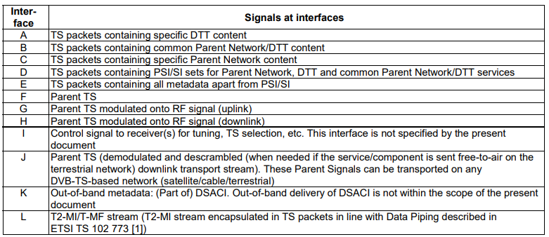

Figure 2b: Conceptual interface within the Single Illumination chain

# 3 Specification of Parent Signals

## 3.1 Overview

The Parent Signals at interface H shall comprise one or more DVB Transport Streams compliant to ISO 13818-1 [5] and suitable for direct reception by DVB-compliant consumer receivers. Those Transport Streams contain DVB services as defined in ETSI EN 300 468 [6] and SIS metadata for generation of the T2-MI or T mega-frame stream at the output of the DSA, i.e. Framing Information as well as DSA Configuration Information for the generation of the DTT multiplex.

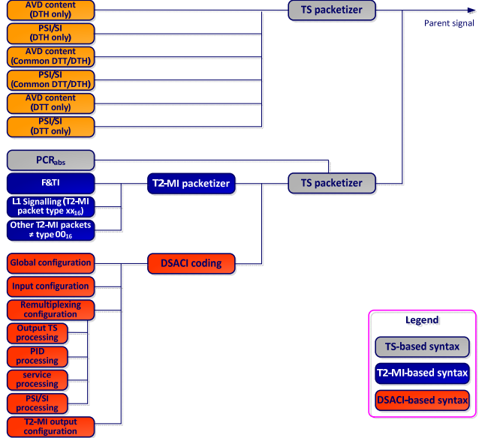

Figure 3.1a: Parent Signal composition illustrating metadata and Audio/Video/Data content, DVB-T2 case

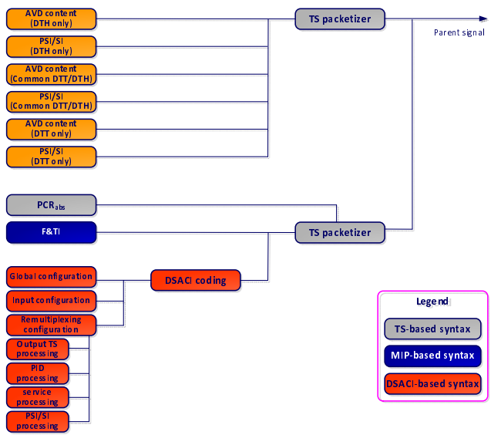

Figure 3.1b: Parent Signal composition illustrating metadata and Audio/Video/Data, DVB-T case

## 3.2 Service Information (PSI/SI)

PSI/SI as defined in ISO 13818-1 [5] and ETSI EN 300 468 [6] shall be part of the Parent Signals for the types of services present in the multiplexes addressing the Daughter Site Adapter (DSA).

* Parent Network-only services
* Common services addressing Parent Network receivers and terrestrial transmitter:
  + The Parent Signal shall also include supplementary PSI/SI for DTT and DSACI Configuration Information, which in combination with the PSI/SI for the Parent Network enables the DSA to generate PSI/SI for the same services when re-transmitted terrestrially. The supplementary DTT PSI/SI is sent compliant to ISO/IEC 13818-1 [5] and ETSI EN 300 468 [6] as described in clause 5.8.

The present document describes different approaches for the generation of DTT PSI/SI, see clause 6.4.4. These approaches will require the following information as part of the Parent Signal:

* + Tables whose provision is stopped:
    - The Parent Signal shall contain indications for stopping the provision of CATs as part of DSACI. - Tables passed through with no change: The Parent Signal shall contain DSACI signaling for PID remapping of the Parent Network PSI/SI table (PID remapping with the same PID on Parent Network and DTT may be used).
  + Tables which are modified using section patching:
    - The Parent Signal shall include Parent Network PSI/SI sections and DSACI signaling for the patching modification.
  + Tables that are regenerated by the DSA:
    - The Parent Signal shall include Parent Network PSI/SI sections and DSACI signaling for the table regeneration and multiplexing.
* DTT-only services, for which PSI/SI is carried as for all other services - with these exceptions:
  + SDT: DTT-only services shall be declared in the Service Description Table as data services, i.e. characterized by service_type 0C16 (data broadcast service).

NOTE: Reference time might be obtained from TDT (UTC there), which is present mandatorily.

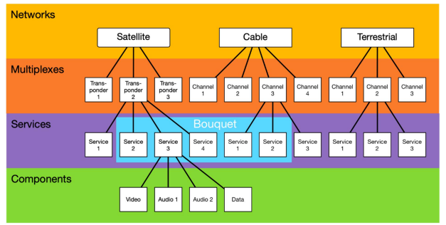

Figure 3.2a: Digital broadcasting, service delivery model

### 3.2-1 SIS Services carrying PCRabs

## 3.3 Service Information description

ISO/IEC 13818-1 [1] specifies SI which is referred to as PSI. The PSI data provides information to enable automatic configuration of the receiver to demultiplex and decode the various streams of programs within the multiplex.

The PSI data is structured as four types of table. The tables are transmitted in sections:

1. Program Association Table (PAT):

For each service in the multiplex, the Program Association Table (PAT) indicates the location (the Packet IDentifier (PID) values of the DVB Transport Stream (TS) packets) of the corresponding Program Map Table (PMT). It also gives the location of the Network Information Table (NIT).

1. Conditional Access Table (CAT):

The Conditional Access Table (CAT) provides information on the Conditional Access (CA) systems used in the multiplex; the information is private (not defined within the present document) and dependent on the CA system, but includes the location of the Entitlement Management Message (EMM) stream, when applicable.

1. Program Map Table (PMT):

The PMT identifies and indicates the locations of the streams that make up each service and the location of the Program Clock Reference fields for a service.

1. Network Information Table (NIT):

The location of the NIT is defined in the present document in compliance with ISO/IEC 13818-1 [1] specification, but the data format is outside the scope of ISO/IEC 13818-1 [1]. It is intended to provide information about the physical network. The syntax and semantics of the NIT are defined in the present document.

In addition to the PSI, data is needed to provide identification of services and events for the user. The coding of this data is defined in the present document. In contrast with the PAT, CAT, and PMT of the PSI, which give information only for the multiplex in which they are contained (the actual multiplex), the additional information defined within the present document can also provide information on services and events carried by different multiplexes, and even on other networks. This data is structured as nine tables:

1. Bouquet Association Table (BAT):

The BAT provides information regarding bouquets. As well as giving the name of the bouquet, it provides a list of services for each bouquet.

1. Service Description Table (SDT):

The SDT contains data describing the services in the system e.g. names of services, the service provider, etc.

1. Event Information Table (EIT):

The EIT contains data concerning events or programmes such as event name, start time, duration, etc.; - the use of different descriptors allows the transmission of different kinds of event information e.g. for different service types.

1. Running Status Table (RST):

The RST gives the status of an event (running/not running). The RST updates this information and allows timely automatic switching to events.

1. Time and Date Table (TDT):

The TDT gives information relating to the present time and date. This information is given in a separate table due to the frequent updating of this information.

1. TOT:

The TOT gives information relating to the present time and date and local time offset. This information is given in a separate table due to the frequent updating of the time information.

1. Stuffing Table (ST):

The ST is used to invalidate existing sections, for example at delivery system boundaries.

1. Selection Information Table (SIT):

The SIT is used only in "partial" (i.e. recorded) bitstreams. It carries a summary of the SI information required to describe the streams in the partial bitstream.

1. Discontinuity Information Table (DIT):

The DIT is used only in "partial" (i.e. recorded) bitstreams. It is inserted where the SI information in the partial bitstream may be discontinuous.

Where applicable the use of descriptors allows a flexible approach to the organization of the tables and allows for future compatible extensions.

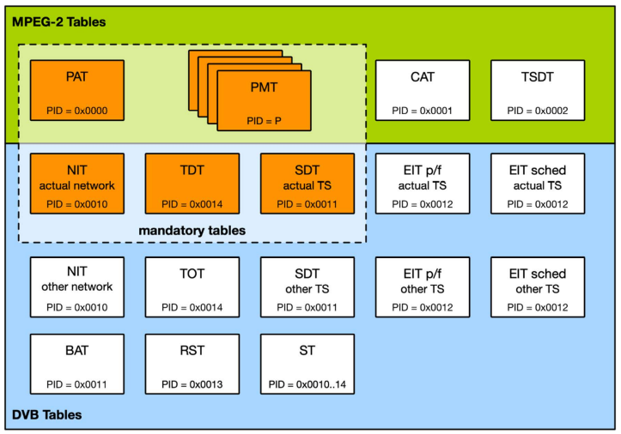

Figure 3.3a: General organization of the SI

## 3.4 Service Information tables

### 3.4-1 Service information table mechanism

#### 3.4-1-1 Use of table sections

The SI specified in this document and MPEG-2 PSI tables shall be segmented into one or more sections before being inserted into TS packets.

The tables listed in clause 4 are conceptual in that they need never be regenerated in a specified form within an IRD. The tables, when transmitted, shall not be scrambled, with the exception of the EIT, which may be scrambled if required (see clause 5.1.5).

A section is a syntactic structure that shall be used for mapping all MPEG-2 tables and SI tables specified in the present document, into TS packets.

These SI syntactic structures conform to the private section syntax defined in ISO/IEC 13818-1 [1].

Sections may be variable in length. The sections within each table are limited to 1 024 bytes in length, except for sections within the EIT which are limited to 4 096 bytes. Each section is uniquely identified by the combination of the following elements:

1. table_id:

The table_id identifies to which table the section belongs. - Some table_ids have been defined by ISO and others by ETSI. Other values of the table_id can be allocated by the user for private purposes. The list of values of table_id is contained in table 2.

1. table_id_extension:

The table_id_extension is used for identification of a sub_table. - The interpretation of each sub_table is given in clause 5.2.

1. Section_number:

The section_number field allows the sections of a particular sub_table to be reassembled in their original order by the decoder. It is recommended that sections are transmitted in numerical order, unless it is desired to transmit some sections of the sub_table more frequently than others, e.g. due to random access considerations. - For the SI tables as specified in the present document, section numbering applies to sub_tables.

1. version_number:

When the characteristics of the TS described in the SI given in the present document change (e.g. new events start, different composition of elementary streams for a given service), then new SI data shall be sent containing the updated information. A new version of the SI data is signalled by sending a sub_table with the same identifiers as the previous sub_table containing the relevant data, but with the next value of version_number. - For the SI tables specified in the present document, the version_number applies to all sections of a sub_table.

1. current_next_indicator:

Each section shall be numbered as valid "now" (current), or as valid in the immediate future (next). This allows the transmission of a future version of the SI in advance of the change, giving the decoder the opportunity to prepare for the change. There is however, no requirement to transmit the next version of a section in advance, but if it is transmitted, then it shall be the next correct version of that section.

### 3.4-2 Mapping of sections into DVB transport stream packets

Sections shall be mapped directly into TS packets. Sections may start at the beginning of the payload of a TS packet, but this is not a requirement, because the start of the first section in the payload of a TS packet is pointed to by the pointer_field. There is never more than one pointer_field in a TS packet, as the start of any other section can be identified by counting the length of the first and any subsequent sections, since no gaps between sections within a TS packet are allowed by the syntax.

Within TS packets of any single PID value, one section is finished before the next one is allowed to be started, or else it is not possible to identify to which section header the data belongs. If a section finishes before the end of a TS packet, but it is not convenient to open another section, a stuffing mechanism may be used to fill up the space.

Stuffing may be performed by filling each remaining byte of the TS packet with the value 0xFF. Consequently the value 0xFF shall not be used for the table_id. If the byte immediately following the last byte of a section takes the value of 0xFF, then the rest of the TS packet shall be stuffed with 0xFF bytes. These bytes may be discarded by a decoder. Stuffing may also be performed using the adaptation_field mechanism.

For a more detailed description of the mechanism and functionality, specifically refer to clause 2.4.4 and annex C of ISO/IEC 13818-1 [1].

### 3.4-3 Coding of PID and table_id fields

Table 1 lists the PID values which shall be used for the TS packets which carry SI sections.

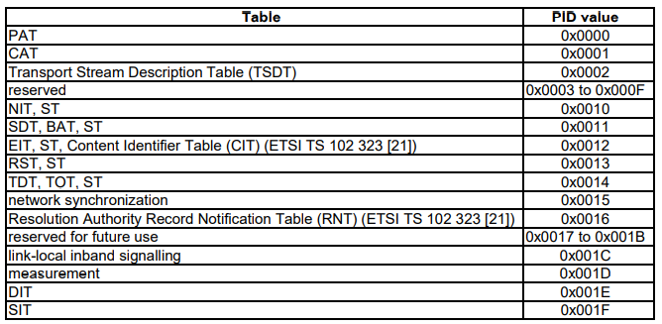

Table 3.4-3a: PID allocation for SI

The PID value 0x001C allocated to link-local inband signaling shall not be used on any broadcast signals. It shall only be used between devices in a controlled environment.

NOTE: The PID 0x001C can for example be used within a broadcast centre, between a receiver device and a Conditional Access Module (CAM), or on private satellite links.

Table 2 lists the values which shall be used for table_id for the service information, defined in the present document.

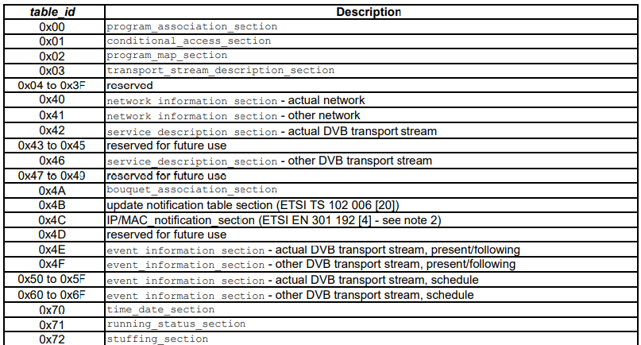

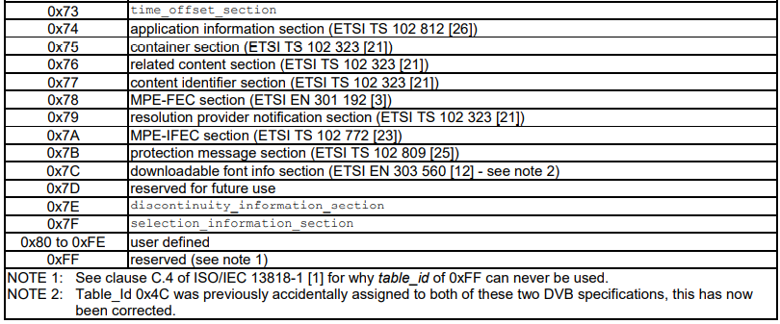

Table 3.4-3b: Allocation of table_id values

### 3.4-4 Repetition rates and random access

In systems where acquisition time of PSI and SI in DVB transport streams is important, it is recommended to continuously re-transmit these sections at regular intervals, even when no changes occur. Clause 4.4 of ETSI TS 101 211 [i.1] makes recommendations for how often PSI and SI sections should be re-transmitted.

For SI specified within the present document the minimum time interval between the arrival of the last byte of a section to the first byte of the next transmitted section with the same PID, table_id and table_id_extension and with the same or different section_number shall be 25 ms. This limit applies for TSs with a total data rate of up to 100 Mbit/s .

### 3.4-5 Scrambling

With the exception of the EIT carrying schedule information, all tables specified in the present document shall not be scrambled. One method for scrambling the EIT schedule table is given in annex E. If a scrambling method operating over TS packets is used, it may be necessary to use a stuffing mechanism to fill from the end of a section to the end of a packet so that any transitions between scrambled and unscrambled data occur at packet boundaries.

In order to identify the CA streams which control the descrambling of the EIT data, a scrambled EIT schedule table shall be identified in the PSI. service_id value 0xFFFF is allocated to identifying a scrambled EIT, and the program map section for this service shall describe the EIT as a private stream and shall include one or more CA_descriptor (defined in ISO/IEC 13818-1 [1]) which give the PID values and optionally, other private data to identify the associated CA streams. service_id value 0xFFFF shall not be used for any other service.

### 3.4-6 Bit order and transmission order

The present clause defines the bit order for encoding unsigned integer (unsigned integer most significant bit first (uimsbf)), bit string (bit string left bit first (bslbf)), two's complement integer (two's complement integer, most significant (sign) bit first (tcimsbf)), and remainder polynomial coefficients (remainder polynomial coefficients highest order first (rpchof)) fields in tables (see clause 5) and descriptors (see clause 6), as well as the order in which these fields are to be transmitted. The present clause also explains and illustrates these provisions.

Within fields, the convention for assigning bit positions -- the bit order -- follows the big-endian convention, i.e. more significant bits are assigned positions with higher index values. This results in the most significant bit (most significant bit (msb)) being assigned the highest index position, and the least significant bit (least significant bit (lsb)) being assigned the lowest index position within a field. Since, by convention, the indices of bit positions count upwards starting from zero, the least significant bit appears at index position zero, denoted as b0. Consequently, when the field is N bits wide, the most significant bit appears at index position N-1. These principles equally apply to all types of fields. Some example fields are shown in figure 3.4-6a.

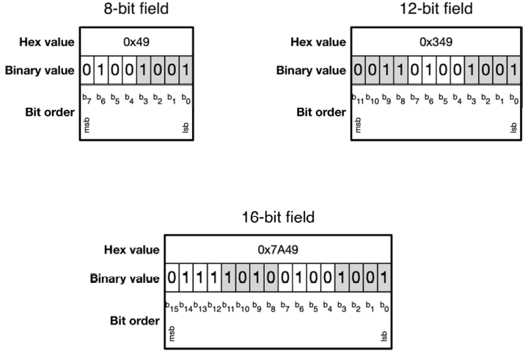

Figure 3.4-6a: Examples of bit order within fields

To define useful elements for conveying service information, the present document defines higher level data structures, like e.g. tables and descriptors, by concatenating various fields of given width and semantics. When such a data structure is to be conveyed to IRDs, it is transmitted over a broadcast link using one of the DVB physical layer standards (e.g. DVB Terrestrial Framing and Modulation (DVB-T), DVB Satellite Framing and Modulation (DVB-S), or DVB Cable Framing and Modulation (DVB-C)). Since all DVB physical layers are bit pipes, any data needs to be serialized into a bit stream before transmission. This serialization follows two rules:

1. The fields comprising a data structure shall be transmitted in the order they appear in the structure's syntax definition, top to bottom.
2. Within each field, the bits shall be transmitted in descending order of index position.

An example for applying these rules is shown in figure 4. Part (a) of figure 4 illustrates rule 1), and shows the syntax definition for the country_availability_descriptor (see clause 6.2.10). The red arrow to the left of the syntax definition table indicates the top to bottom sequence of transmission of the fields. Part (b) of figure 4 illustrates rule 2), and shows how the bits comprising the fields are serialized. Again, the red arrow below the serialization indicates the sequence of transmission in descending order of index position. For reference, some example values for the fields have been chosen, and their hexadecimal representation is also given.

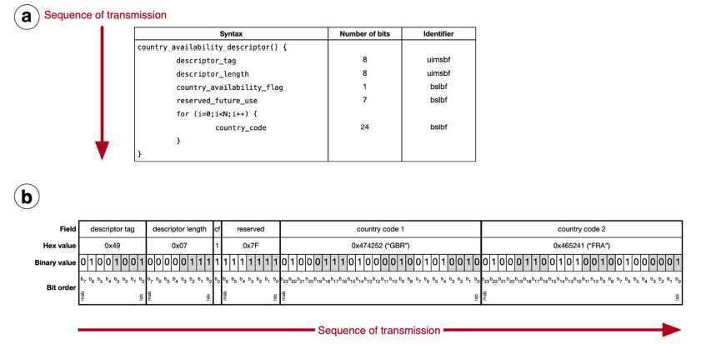

Figure 3.4-6b:Example of transmission order

Based on these rules, the names "unsigned integer, most significant bit first" (uimsbf) for unsigned integer fields, and "bit string, left bit first" (bslbf) for bit string fields are conveniently explained.

Unsigned integer fields represent numbers within a polyadic number system, which are composed of digits and where the position of each digit indicates to which power of the number system's base the digit refers. Due to the use of the big-endian convention for the bit order within each field, the most significant bit (msb) of an N-bit unsigned integer field is assigned the highest possible index N-1. Following rule 2) (transmission in descending order of index position), the most significant bit of a field is transmitted first, and the least significant bit is transmitted last. Hence the name of "unsigned integer, most significant bit first" (uimsbf).

Bit string fields - as opposed to unsigned integer fields - do not represent numbers, and hence their bit index positions are not associated with higher or lower significance of the bits, but only serve to uniquely identify the bits within a field. To still allow unambiguous serialization and deserialization of bit string fields, the provisions of the present document use the bit index positions b1, b2, b3, etc. to define the encoding and semantics of each bit in a bit string field. When all bits of a bit string field are rendered in printing according to the big-endian convention, the bit with the highest index position N-1 appears on the left, and the bit with the lowest index position zero appears on the right. Following rule 2) (transmission in descending order of index position), the bit with the highest index position (appearing on the left) is transmitted first. Hence the name of "bit string, left bit first" (bslbf).

## 3.5 Table definitions

### 3.5-1 Introduction

The following clauses describe the syntax and semantics of the different types of table.

NOTE: The symbols and abbreviations, and the method of describing syntax used in the present document are the same as those defined in clause 2.2 and clause 2.3 of ISO/IEC 13818-1 [1]

### 3.5-2 Network Information Table

The NIT (see table 3) conveys information relating to the physical organization of the multiplexes/TSs carried via a given network, and the characteristics of the network itself. The combination of original_network_id and transport_stream_id allow each TS to be uniquely identified throughout the application area of the present document. Networks are assigned individual network_id values, which serve as unique identification codes for networks. The allocation of these codes is specified in ETSI TS 101 162 [15].

The network_id and the original_network_id can take the same value, or may have to take different values subject to the allocation constraints for original_network_id and network_id as are defined in ETSI TS 101 162 [15]. Guidelines for the processing of SI at transitions between delivery system boundaries, e.g. from satellite to cable or Satellite Master Antenna TeleVision (SMATV) systems, can be found in ETSI TS 101 211 [i.1].

IRDs may be able to store the NIT information in non-volatile memory in order to minimize the access time when switching between channels ("channel hopping"). It is also possible to transmit a NIT for other networks in addition to the actual network. Differentiation between the NIT for the actual network and the NIT for other networks is achieved using different table_id values (see table 2).

The NIT shall be segmented into network_information_section using the syntax of table 3. Any sections forming part of an NIT shall be transmitted in TS packets with a PID value of 0x0010. Any sections of the NIT which describe the actual network (that is, the network of which the TS containing the NIT is a part) shall have the table_id 0x40 with the same table_id_extension (network_id). The network_id field shall take the value assigned to the actual network according to ETSI TS 101 162 [15]. Any sections of a NIT which refer to a network other than the actual network shall take a table_id value of 0x41 and the network_id shall take the value assigned to the other network according to ETSI TS 101 162 [15].

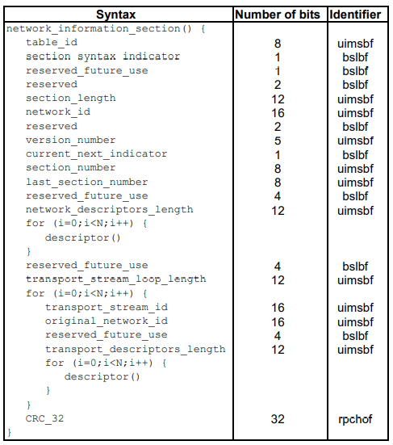

Figure 3.5-2a: Network Information section

Semantics for the network information section

**table_id**: See table 2.

**section_syntax_indicator**: This 1-bit field shall be set to 0b1.

**section_length**: This is a 12-bit field, the first two bits of which shall be 0b00. It specifies the number of bytes of the section, starting immediately following the section_length field and including the Cyclic Redundancy Check (CRC). The value in the section_length field shall not exceed 1021 so that the entire section has a maximum length of 1024 bytes.

**network_id**: This is a 16-bit field which serves as a label to identify the delivery system, about which the NIT informs, from any other delivery system. It shall be coded according to ETSI TS 101 162 [15].

**version_number**: This 5-bit field is the version number of the sub_table. The version_number shall be incremented by 1 when a change in the information carried within the sub_table occurs. When it reaches value 31, it wraps around to 0. When the current_next_indicator is set to 0b1, then the version_number shall be that of the currently applicable sub_table. When the current_next_indicator is set to 0b0, then the version_number shall be that of the next applicable sub_table.

**current_next_indicator**: This 1-bit indicator, when set to 0b1 indicates that the sub_table is the currently applicable sub_table. When the bit is set to 0b0, it indicates that the sub_table sent is not yet applicable and shall be the next sub_table to be valid.

**section_number**: This 8-bit field gives the number of the section. The section_number of the first section in the sub_table shall be 0x00. The section_number shall be incremented by 1 with each additional section with the same table_id and network_id.

**last_section_number**: This 8-bit field specifies the number of the last section (that is, the section with the highest section_number) of the sub_table of which this section is part.

**network_descriptors_length**: This 12-bit field gives the total length in bytes of the following descriptors. transport_stream_loop_length: This is a 12-bit field specifying the total length in bytes of the TS loops that follow, ending immediately before the first CRC_32 byte.

**transport_stream_id**: This is a 16-bit field which serves as a label for identification of this TS from any other multiplex within the delivery system.

**original_network_id**: This 16-bit field gives the label identifying the network_id of the originating delivery system.

**transport_descriptors_length**: This is a 12-bit field specifying the total length in bytes of TS descriptors that follow.

**CRC_32**: This is a 32-bit field that contains the CRC value that gives a zero output of the registers in the decoder defined in annex A of ISO/IEC 13818-1 [1] after processing the entire section.

### 3.5-3 Bouquet Association Table

The BAT (see table 4) provides information regarding bouquets. A bouquet is a collection of services, which may traverse the boundary of a network.

The BAT shall be segmented into bouquet_association_sections using the syntax of table 4. Any section forming part of a BAT shall be transmitted in TS packets with a PID value of 0x0011. The sections of a BAT sub_table describing a particular bouquet shall have the bouquet_id field taking the value assigned to the bouquet according to ETSI TS 101 162 [15]. All BAT sections shall take a table_id value of 0x4A.

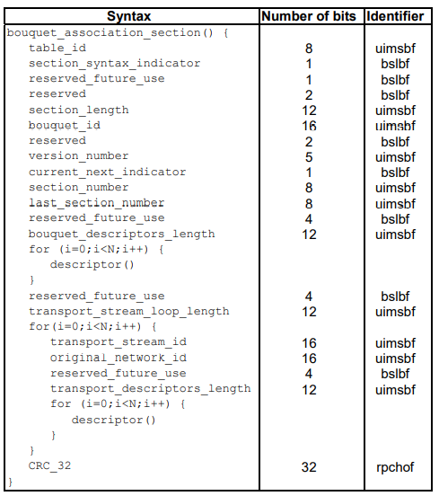

Table 3.5-2b: Bouquet association section

Semantics for the bouquet association

**section table_id**: See table 2.

**section_syntax_indicator**: This 1-bit field shall be set to 0b1.

**section_length**: This is a 12-bit field, the first two bits of which shall be 0b00. It specifies the number of bytes of the section, starting immediately following the section_length field and including the CRC. The value in the section_length field shall not exceed 1 021 so that the entire section has a maximum length of 1 024 bytes.

**bouquet_id**: This is a 16-bit field which serves as a label to identify the bouquet. It shall be coded according to ETSI TS 101 162 [15].

**version_number**: This 5-bit field is the version number of the sub_table. The version_number shall be incremented by 1 when a change in the information carried within the sub_table occurs. When it reaches value 31, it wraps around to 0. When the current_next_indicator is set to 0b1, then the version_number shall be that of the currently applicable sub_table. When the current_next_indicator is set to 0b0, then the version_number shall be that of the next applicable sub_table.

**current_next_indicator**: This 1-bit indicator, when set to 0b1 indicates that the sub_table is the currently applicable sub_table. When the bit is set to 0b0, it indicates that the sub_table sent is not yet applicable and shall be the next sub_table to be valid.

**section_number**: This 8-bit field gives the number of the section. The section_number of the first section in the sub_table shall be 0x00. The section_number shall be incremented by 1 with each additional section with the same table_id and bouquet_id.

**last_section_number**: This 8-bit field specifies the number of the last section (that is, the section with the highest section_number) of the sub_table of which this section is part.

**bouquet_descriptors_length**: This 12-bit field gives the total length in bytes of the following descriptors.

**transport_stream_loop_length**: This is a 12-bit field specifying the total length in bytes of the TS loops that follow, ending immediately before the first CRC_32 byte.

**transport_stream_id**: This is a 16-bit field which serves as a label for identification of this TS from any other multiplex within the delivery system.

**original_network_id**: This 16-bit field gives the label identifying the network_id of the originating delivery system.

**transport_descriptors_length**: This is a 12-bit field specifying the total length in bytes of TS descriptors that follow. CRC_32: This is a 32-bit field that contains the CRC value that gives a zero output of the registers in the decoder defined in annex A of ISO/IEC 13818-1 [1] after processing the entire section.

### 3.5-4 Service Description Table

Each sub_table of the SDT (see table 5) shall describe services that are contained within a particular TS. The services may be part of the actual TS or part of other TSs, these being identified by means of the table_id (see table 2).

The SDT shall be segmented into service_description_sections using the syntax of table 5. Any sections forming part of an SDT shall be transmitted in TS packets with a PID value of 0x0011. Any sections of the SDT which describe the actual TS (that is, the TS containing the SDT) shall have the table_id value 0x42 with the same table_id_extension (transport_stream_id) and with the same original_network_id. Any sections of an SDT which refer to a TS other than the actual TS shall take a table_id value of 0x46.

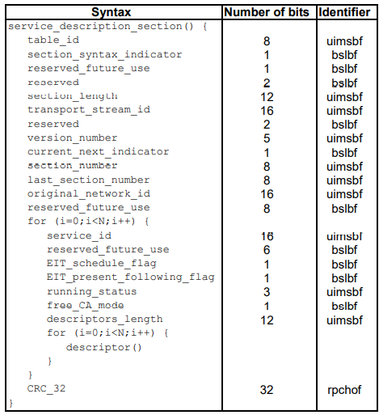

**Table 3.5-4a:** Service description section

Semantics for the service description section

**table_id**: See table 2.

**section_syntax_indicator**: This 1-bit field shall be set to 0b1.

**section_length**: This is a 12-bit field, the first two bits of which shall be 0b00. It specifies the number of bytes of the section, starting immediately following the section_length field and including the CRC. The value in the section_length field shall not exceed 1 021 so that the entire section has a maximum length of 1 024 bytes.

**transport_stream_id**: This is a 16-bit field which serves as a label for identification of this TS from any other multiplex within the delivery system.

**version_number**: This 5-bit field is the version number of the sub_table. The version_number shall be incremented by 1 when a change in the information carried within the sub_table occurs. When it reaches value 31, it wraps around to 0. When the current_next_indicator is set to 0b1, then the version_number shall be that of the currently applicable sub_table. When the current_next_indicator is set to 0b0, then the version_number shall be that of the next applicable sub_table.

**current_next_indicator**: This 1-bit indicator, when set to 0b1 indicates that the sub_table is the currently applicable sub_table. When the bit is set to 0b0, it indicates that the sub_table sent is not yet applicable and shall be the next sub_table to be valid.

**section_number**: This 8-bit field gives the number of the section. The section_number of the first section in the sub_table shall be 0x00. The section_number shall be incremented by 1 with each additional section with the same table_id, transport_stream_id, and original_network_id.

**last_section_number**: This 8-bit field specifies the number of the last section (that is, the section with the highest section_number) of the sub_table of which this section is part.

**original_network_id**: This 16-bit field gives the label identifying the network_id of the originating delivery system. service_id: This is a 16-bit field which serves as a label to identify this service from any other service within a TS. The service_id is the same as the program_number in the corresponding program_map_section, except that in the case of service_type = 0x04, 0x18, or 0x1B (Near Video On Demand (NVOD) reference services) the service_id does not have a corresponding program_number.

**EIT_schedule_flag**: This is a 1-bit field which when set to 0b1 indicates that EIT schedule information for the service is present in the current TS (see ETSI TS 101 211 [i.1] for information on maximum time interval between occurrences of an EIT schedule sub_table). If the flag is set to 0b0 then the EIT schedule information for the service should not be present in the TS.

**EIT_present_following_flag**: This is a 1-bit field which when set to 0b1 indicates that EIT present/following information for the service is present in the current TS (see ETSI TS 101 211 [i.1] for information on maximum time interval between occurrences of an EIT present/following sub_table). If the flag is set to 0b0 then the EIT present/following information for the service should not be present in the TS.

**running_status**: This is a 3-bit field indicating the status of the service as defined in table 3.5-4b.

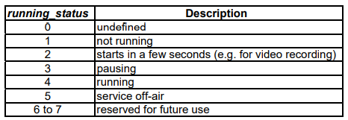

Table 3.5-4b: Running status

For an NVOD reference service the value of the running_status shall be set to 0.

**free_CA_mode**: This 1-bit field, when set to 0b0 indicates that all the component streams of the service are not scrambled. When set to 0b1 it indicates that access to one or more streams may be controlled by a conditional access system.

**descriptors_length**: This 12-bit field gives the total length in bytes of the following descriptors.

**CRC_32**: This is a 32-bit field that contains the CRC value that gives a zero output of the registers in the decoder defined in annex A of ISO/IEC 13818-1 [1] after processing the entire section.

### 3.5-5 Event Information Table

The EIT (see table 7) provides information in chronological order regarding the events contained within each service. Four classifications of EIT have been identified, distinguishable by the use of different table_ids (see table 2):

1. actual TS, present/following event information = table_id = 0x4E;
2. other TS, present/following event information = table_id = 0x4F;
3. actual TS, event schedule information = table_id = 0x50 to 0x5F;
4. other TS, event schedule information = table_id = 0x60 to 0x6F.

All EIT sub_tables for the actual DVB transport stream shall have the same transport_stream_id and original_network_id values.

The EIT present/following table shall contain only information pertaining to the present event and the chronologically following event carried by a given service on either the actual TS or another TS, except in the case of a NVOD reference service where it may have more than two event descriptions. The EIT present/following table is optional. Its presence or absence shall be signaled by setting the EIT_present_following_flag in the SDT.

The event schedule tables for either the actual TS or other TSs, contain a list of events, in the form of a schedule including events other than the present and following events. The EIT schedule tables are optional. Their presence or absence shall be signaled by setting the EIT_schedule_flag in the SDT. The event information shall be chronologically ordered.

The EIT shall be segmented into event_information_sections using the syntax of table 7. Any sections forming part of an EIT shall be transmitted in TS packets with a PID value of 0x0012.

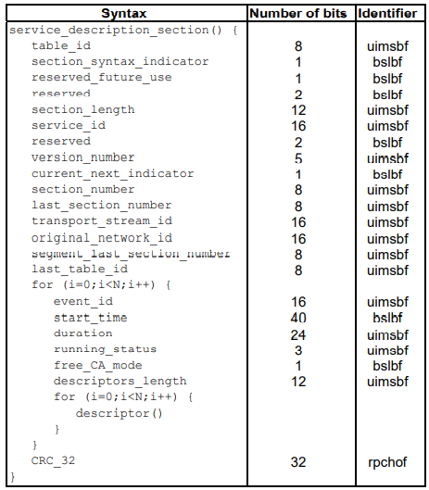

Table 3.5-5a: Event information section

Semantics for the event information section

**table_id**: See table 2.

**section_syntax_indicator**: This 1-bit field shall be set to 0b1.

**section_length**: This is a 12-bit field. It specifies the number of bytes of the section, starting immediately following the section_length field and including the CRC. The section_length shall not exceed 4 093 so that the entire section has a maximum length of 4 096 bytes.

**service_id**: This is a 16-bit field which serves as a label to identify this service from any other service within a TS. The service_id is the same as the program_number in the corresponding program_map_section, except that in the case of service_type = 0x04, 0x18, or 0x1B (NVOD reference services) the service_id does not have a corresponding program_number.

**version_number**: This 5-bit field is the version number of the sub_table. The version_number shall be incremented by 1 when a change in the information carried within the sub_table occurs. When it reaches value 31, it wraps around to 0. When the current_next_indicator is set to 0b1, then the version_number shall be that of the currently applicable sub_table. When the current_next_indicator is set to 0b0, then the version_number shall be that of the next applicable sub_table.

**current_next_indicator**: This 1-bit indicator, when set to 0b1 indicates that the sub_table is the currently applicable sub_table. When the bit is set to 0b0, it indicates that the sub_table sent is not yet applicable and shall be the next sub_table to be valid.

**section_number**: This 8-bit field gives the number of the section. The section_number of the first section in the sub_table shall be 0x00. The section_number shall be incremented by 1 with each additional section with the same table_id, service_id, transport_stream_id, and original_network_id. In this case, the sub_table may be structured as a number of segments. Within each segment the section_number shall increment by 1 with each additional section, but a gap in numbering is permitted between the last section of a segment and the first section of the adjacent segment.

**last_section_number**: This 8-bit field specifies the number of the last section (that is, the section with the highest section_number) of the sub_table of which this section is part.

**transport_stream_id**: This is a 16-bit field which serves as a label for identification of this TS from any other multiplex within the delivery system.

**original_network_id**: This 16-bit field gives the label identifying the network_id of the originating delivery system.

**segment_last_section_number**: This 8-bit field specifies the number of the last section of this segment of the sub_table. For sub_tables which are not segmented, this field shall be set to the same value as the last_section_number field.

**last_table_id**: This 8-bit field identifies the last table_id used (see table 2). For EIT present/following tables, this field shall be set to the same value as the table_id field. For EIT schedule tables with table_id in the range 0x50 to 0x5F, this field shall be set to the largest table_id transmitted in this range for this service. For EIT schedule tables with table_id in the range 0x60 to 0x6F, this field shall be set to the largest table_id transmitted in this range for this service.

NOTE: This implies that the value of last_table_id may be different for each service.

EXAMPLE 1: The table below shows some examples of last_table_id values for two services.

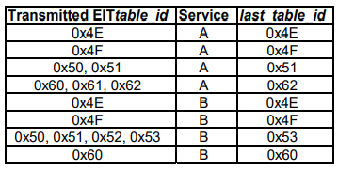

Table 3.5-5b: Examples of last_table_id values

**event_id**: This 16-bit field contains the identification number of the described event (uniquely allocated within a service definition).

**start_time**: This 40-bit field contains the start time of the event in Universal Time, Co-ordinated (UTC) and Modified Julian Date (MJD) (see annex C). This field is coded as 16 bits giving the 16 lsb of MJD followed by 24 bits coded as 6 digits in 4-bit Binary Coded Decimal (BCD). If the start time is undefined (e.g. for an event in a NVOD reference service) all bits of the field are set to 0b1.

EXAMPLE 2: 93/10/13 12:45:00 is coded as 0xC0 7912 4500.

**duration**: This 24-bit field indicates the duration of the event in hours, minutes, and seconds coded as 6 digits in 4-bit BCD.

EXAMPLE 3: 01:45:30 is coded as 0x01 4530.

**running_status**: This is a 3-bit field indicating the status of the event as defined in table 6. For an NVOD reference event the value of the running_status shall be set to 0b0.

**free_CA_mode**: This 1-bit field, when set to 0b0 indicates that all the component streams of the event are not scrambled. When set to 0b1 it indicates that access to one or more streams may be controlled by a conditional access system.

**descriptors_length**: This 12-bit field gives the total length in bytes of the following descriptors. CRC_32: This is a 32-bit field that contains the CRC value that gives a zero output of the registers in the decoder defined in annex A of ISO/IEC 13818-1 [1] after processing the entire section.

### 3.5-6 Time and Date Table

The TDT (see table 8) carries only the UTC time and date information.

The TDT shall consist of a single section using the syntax of table 8. This TDT section shall be transmitted in TS packets with a PID value of 0x0014, and the table_id shall take the value 0x70.

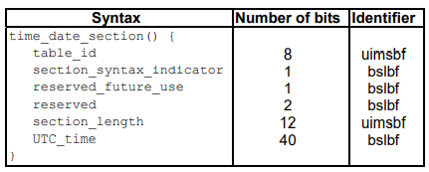

Table 3.5-6a: Time and date section

Semantics for the time and date section

**table_id**: See table 2.

**section_syntax_indicator**: This 1-bit field shall be set to 0b0.

**section_length**: This is a 12-bit field, the first two bits of which shall be 0b00. It specifies the number of bytes of the section, starting immediately following the section_length field and up to the end of the section.

**UTC_time**: This 40-bit field contains the current time and date in UTC and MJD (see annex C). This field is coded as 16 bits giving the 16 lsb of MJD followed by 24 bits coded as 6 digits in 4-bit BCD.

EXAMPLE: 93/10/13 12:45:00 is coded as 0xC0 7912 4500.

### 3.5-7 Time Offset Table

The TOT (see table 9) carries the UTC time and date information and local time offset. The TOT shall consist of a single section using the syntax of table 9. This TOT section shall be transmitted in TS packets with a PID value of 0x0014, and the table_id shall take the value 0x73.

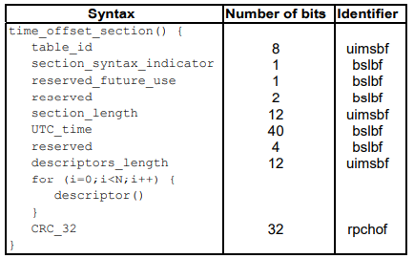

**Table 3.5-7a**: Time offset section

Semantics for the time offset section

**table_id**: See table 2.

**section_syntax_indicator**: This 1-bit field shall be set to 0b0.

**section_length**: This is a 12-bit field, the first two bits of which shall be 0b00. It specifies the number of bytes of the section, starting immediately following the section_length field and up to the end of the section.

**UTC_time**: This 40-bit field contains the current time and date in UTC and MJD (see annex C). This field is coded as 16 bits giving the 16 lsb of MJD followed by 24 bits coded as 6 digits in 4-bit BCD.

EXAMPLE: 93/10/13 12:45:00 is coded as 0xC0 7912 4500.

**descriptors_length**: This 12-bit field gives the total length in bytes of the following descriptors.

**CRC_32**: This is a 32-bit field that contains the CRC value that gives a zero output of the registers in the decoder defined in annex A of ISO/IEC 13818-1 [1] after processing the entire section.

### 3.5-8 Running Status Table

The RST (see table 10) allows accurate and rapid updating of the timing status of one or more events. This may be necessary when an event starts early or late due to scheduling changes. The use of a separate table enables fast updating mechanisms to be achieved.

The RST shall be segmented into running_status_sections using the syntax of table 10. Any sections forming part of an RST shall be transmitted in TS packets with a PID value of 0x0013, and the table_id shall take the value 0x71.

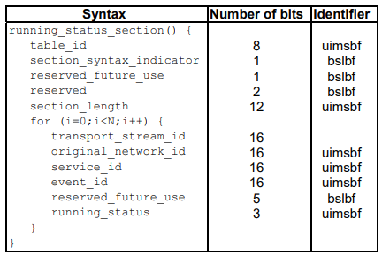

Table 3.5-8a: Running status section

Semantics for the running status

**section** table_id: See table 2.

**section_syntax_indicator**: This 1-bit field shall be set to 0b0.

**section_length**: This is a 12-bit field, the first two bits of which shall be 0b00. It specifies the number of bytes of the section, starting immediately following the section_length field and up to the end of the section. The section_length shall not exceed 1 021 so that the entire section has a maximum length of 1 024 bytes.

**transport_stream_id**: This is a 16-bit field which serves as a label for identification of this TS from any other multiplex within the delivery system.

**original_network_id**: This 16-bit field gives the label identifying the network_id of the originating delivery system.

**service_id**: This is a 16-bit field which serves as a label to identify this service from any other service within a TS. The service_id is the same as the program_number in the corresponding program_map_section, except that in the case of service_type = 0x04, 0x18, or 0x1B (NVOD reference services) the service_id does not have a corresponding program_number.

**event_id**: This 16-bit field contains the identification number of the related event. running_status: This is a 3-bit field indicating the status of the event as defined in table 6.

### 3.5-9 Stuffing Table

The purpose of this clause (see table 11) is to invalidate existing sections at a delivery system boundary e.g. at a cable head-end. When one section of a sub_table is overwritten, then all the sections of that sub_table shall also be overwritten (stuffed) in order to retain the integrity of the section_number field.

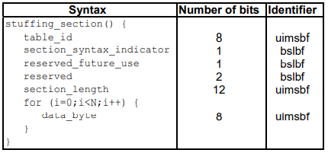

Table 3.5-9a: Stuffing section

Semantics for the stuffing

**section table_id**: See table 2.

**section_syntax_indicator**: This 1-bit field may take either the value 0b1 or 0b0.

**section_length**: This is a 12-bit field. It specifies the number of bytes of the section, starting immediately following the section_length field and up to the end of the section. The value in the section_length field shall not exceed 4 093 so that the entire section has a maximum length of 4 096

**bytes. data_byte**: This 8-bit field may take any value and has no meaning.

### 3.5-10 Discontinuity Table

### 3.5-11 Selection Information Table

## 3.6 Descriptors

### 3.6-1 Introduction

This clause describes the different descriptors that can be used within the SI (for further information refer to the document, see ETSI TS 101 211 [i.1]).

#### 3.6-1-1 Descriptor identification and location

Table 3.6-1-1a lists the descriptors declared or defined within the present document, giving the descriptors-tag values and the intended placement within the SI tables. This does not imply that their use in other tables is restricted.

Table 3.6-1-1a uses the following mark-up to indicate the possible locations of descriptors:

* a check mark ("✓ ") indicates that the descriptor may be carried in the respective table;
* a dash ("-") indicates that the descriptor shall not be carried in the respective table;
* an empty table cell indicates that nothing is implied regarding the carriage of the descriptor in the respective table.

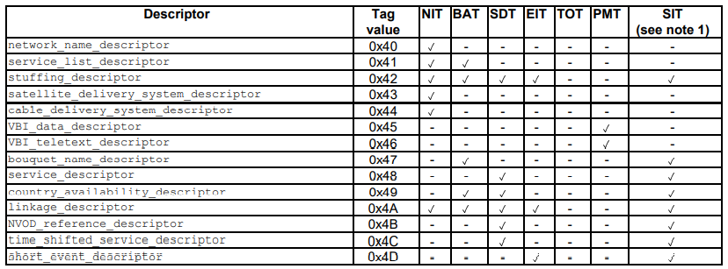

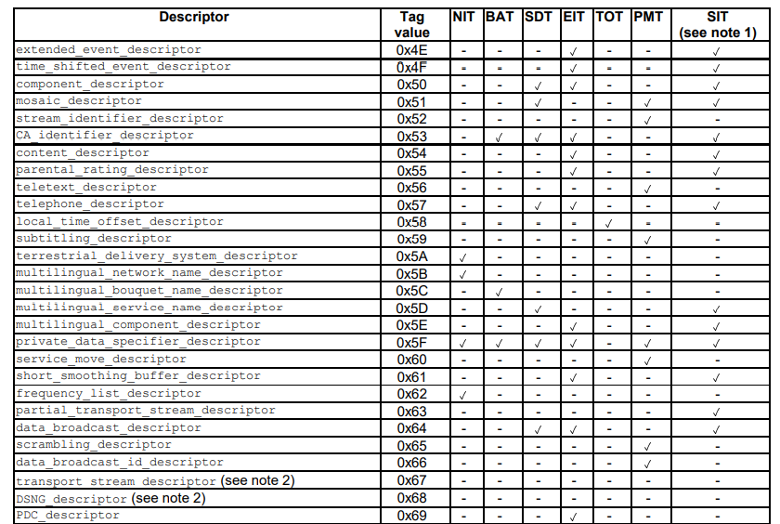

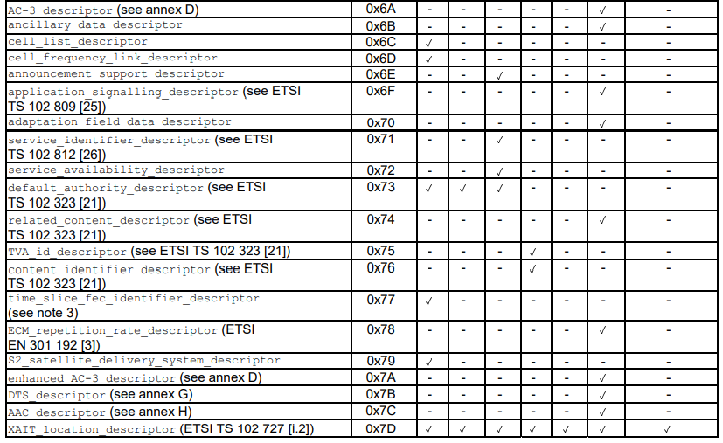

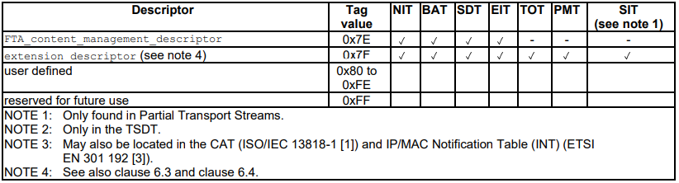

Table 3.6-1-1a: Possible locations of descriptors

### 3.6-2 Descriptor coding

#### 3.6-2-1 General principles

When the construct descriptor() appears in the sections of clause 5.2, this indicates that zero or more of the descriptors defined in clause 6.2 shall occur.

The following semantics apply to all the descriptors defined in clause 6.2.

**descriptor_tag**: The descriptor_tag is an 8-bit field which identifies each descriptor. Those values with MPEG-2 normative meaning are described in ISO/IEC 13818-1 [1]. The values of descriptor_tag are defined in table 3.6-2-1a.

**descriptor_length**: The descriptor_length is an 8-bit field specifying the total number of bytes of the data portion of the descriptor following the byte defining the value of this field.

The bit and transmission ordering rules defined in clause 5.1.6 shall apply.

#### 3.6-2-2 Adaptation field data descriptor

The adaptation_field_data_descriptor (see table 13) provides a means of indicating the type of data fields supported within the private data field of the adaptation field. These data fields shall be coded according to annex D of ETSI TS 101 154 [14]. This descriptor shall be inserted into the corresponding ES_info loop of the PMT if the stream contains one or more of the data fields listed in table 3.6-2-2b.

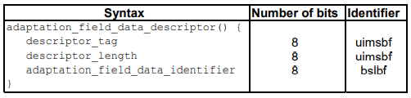

Table 3.6-2-2a: Adaptation field data descriptor

Semantics for the adaptation field data descriptor

**adaptation_field_data_identifier**: This is an 8-bit field identifying data fields transmitted in the private data bytes of the adaptation field. It shall be coded according to table 14. If a bit in the adaptation_field_data_identifier is set to 0b1 it indicates that the transmission of the corresponding data field (as specified in the standard identified in the description column) is supported.

NOTE: The data field does not necessarily occur in every adaptation field.

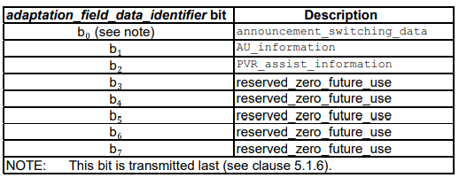

Table 3.6-2-2b: Adaptation field data identifier coding

#### 3.6-2-3 ancillary data descriptor

The ancillary_data_descriptor (see table 15) provides a means of indicating the presence and the type of ancillary data in audio elementary streams coded according to clause 6.1 of ETSI TS 101 154 [14]. It shall be inserted into the corresponding ES_info loop of the PMT. If the ancillary data adheres to one of the formats in table 16, the descriptor shall be present.

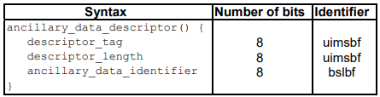

Table 3.6-2-3a: Ancillary data descriptor

Semantics for the ancillary data descriptor

**ancillary_data_identifier**: This is an 8-bit field identifying ancillary data coded in the audio elementary stream. It shall be coded according to table 16. If a bit in the ancillary_data_identifier field is set to 0b1 it indicates that ancillary data includes the corresponding data field.

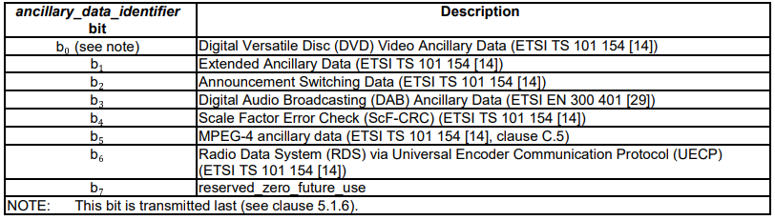

Table 3.6-2-3a:Ancillary data identifier coding

#### 3.6-2-4 Announcement support descriptor

The announcement_support_descriptor (see table 17) identifies the type of announcements that are supported by the service. Furthermore, it informs about the transport method of the announcement and gives the necessary linkage information so that the announcement stream can be monitored.

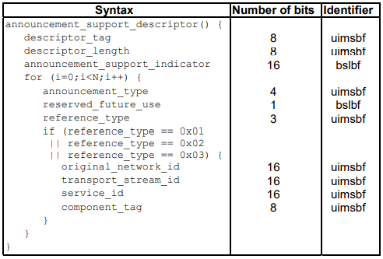

Table 3.6-2-4a: Announcement support descriptor

Semantics for the announcement support descriptor

**announcement_support_indicator**: The announcement support indicator is a 16-bit flag field specifying which types of announcements are supported by the service. The field shall be coded according to clause C.4.3 of ETSI TS 101 154 [14].

announcement_type: This 4-bit field specifies the type of announcement for which the following fields in the loop are valid, see table 3.6-2-4b coding.

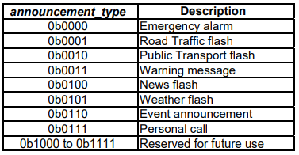

Table 3.6-2-4b: Announcement type coding

reference_type: This is a 3-bit field. It specifies the transport method of the announcement according to table 3.6-2-4c.

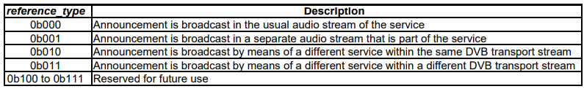

Table 3.6-2-4c: Reference type coding

**original_network_id**: This 16-bit field gives the label identifying the network_id of the originating delivery system of the announcement service indicated.

**transport_stream_id**: This is a 16-bit field which uniquely identifies the TS containing the announcement service indicated.

**service_id**: This is a 16-bit field which uniquely identifies the service containing the announcements indicated.

**component_tag**: This 8-bit field has the same value as the component_tag field in the stream identifier descriptor that shall be present in the PSI program map section for the audio stream on which the announcement is broadcast.

#### 3.6-2-5 Bouquet name descriptor

The bouquet_name_descriptor provides the bouquet name in text form, see table 3.6-2-5a.

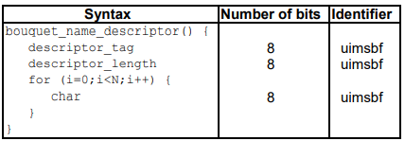

Table 3.6-2-5a: Bouquet name descriptor

Semantics for the bouquet name descriptor

**char**: This is an 8-bit field, a sequence of which conveys the name of the bouquet about which the BAT sub_table informs. Text information is coded using the character sets and methods described in annex A.

#### 3.6-2-6 CA identifier descriptor

#### 3.6-2-7 Cell frequency link descriptor

#### 3.6-2-8 Cell list descriptor

#### 3.6-2-9 Component descriptor

#### 3.6-2-10 Content descriptor

#### 3.6-2-11 Country availability descriptor

#### 3.6-2-12 Data broadcast descriptor

#### 3.6-2-13 Data broadcast descriptor

#### 3.6-2-14 Delivery system descriptors

##### 3.6-2-14-1 Cable delivery system descriptor

##### 3.6-2-14-2 Satellite delivery system descriptor

##### 3.6-2-14-3 S2 satellite delivery system descriptor

##### 3.6-2-14-4 Terrestrial delivery system descriptor

#### 3.6-2-15 DSNG descriptor

#### 3.6-2-16 Extended descriptor

#### 3.6-2-17 Extension descriptor

#### 3.6-2-18 Frequency list descriptor

#### 3.6-2-19 FTA content management descriptor

##### 3.6-2-19-1 Semantics and syntax of the linkage descriptor

##### 3.6-2-19-2 Scope of the FTA content management descriptor

#### 3.6-2-20 Linkage descriptor

#### 3.6-2-20-1 Semantics Linkage descriptor

#### 3.6-2-20-1 Linkage descriptor

#### 3.6-2-20-1 Linkage descriptor

#### 3.6-2-20-1 Linkage descriptor

#### 3.6-2-21 Local time offset descriptor

#### 3.6-2-22

#### 3.6-2-23

### 3.6-3 Extended descriptor identification and location

### 3.6-4 Extended descriptor coding

#### 3.6-4-1 General principles

#### 3.6-4-7 Delivery system descriptors

#### 3.6-4-7-1 C2 delivery system descriptor

#### 3.6-4-7-2 C2 delivery system descriptor

#### 3.6-4-7-3 C2 delivery system descriptor

#### 3.6-4-7-4 C2 delivery system descriptor

#### 3.6-4-7-5 C2 delivery system descriptor

#### 3.6-4-8 Image icon descriptor

#### 3.6-4-17 Video depth range descriptor

##### 3.6-4-17-1

##### 3.6-4-17-2

### 3.6-5 Scoping rules for scoping descriptors

## 3.7 Storage Media Interoperability measures

### 3.7-1 Introduction

### 3.7-2

### 3.7-3

#### 3.7-3-1 General principles

#### 3.7-3-2 General principles

#### 3.7-3-3 General principles

### 3.7-4 SMI descriptors

#### 3.7-4-1 Introduction

#### 3.7-4-2 Partial transport stream descriptor

#### 

### 

#### 

#### 

#### 

#### 

#### 

#### 

#### 

##### 

##### 

#### 

# 4 Control Signal/Stream Generator (CSG)

Control Signal Generator produces all metadata required:

## 4.1 Layer 1 Signaling:

### 4.1-1 DVB-T2 case

### 4.1-2 DVB-T case

## 4.2 Other T2-MI packet types (DVB-T2 case)

## 4.3 Framing & Timing Information (F&TI)

### 4.3-2 Overview

### 4.3-3 DVB-T2 case

### 4.3-4 DVB-T case

## 4.4 DSA Configuration Information (DSACI)

### 4.4-1 Overview

### 4.4-2 DSACI Structure

#### 4.4-2-1 XML schema representation

### 4.4-3 XML types and XML elements of the DSA Configuration Information

#### 4.4-3-1 Global Configuration¤

##### 4.4-3-1-1 Overview

#### 4.4-3-2 Input Configuration

##### 4.4-3-2-1 Overview

#### 4.4-3-3 Remultiplexing

#### 4.4-3-4 PID processing

#### 4.4-3-5 Service and PMT processing

#### 4.4-3-6 PSI/SI

#### 4.4-3-7 PAT processing

#### 4.4-3-8 CAT processing

#### 4.4-3-9 SDT and BAT processing

#### 4.4-3-10 EIT processing

#### 4.4-3-11 Output configuration

#### 

#### 

## 

# 5 Daughter Site Adapter (DSA)

## 5.1 Overview (DVB-T2 and-T cases)

## 5.2 Bootstrapping

### 5.2-1 Overview

### 5.2-2 Gaining access to DSACI provided in-band

### 5.2-3 Out-of-band DSACI provision

## 5.3 Input processing

### 5.3-1 Reception of parent Transport Streams

#### 5.3-1-1 Overview

#### 5.3-1-2 Arrival timestamping

#### 5.3-1-3 Calculation of Virtual Arrival Timestamp (VATs)

##### 5.3-1-3-1 Overview

##### 5.3-1-3-2 CBR operation mode

## 5.4 TS re-multiplexing

### 5.4-1 Overview

### 5.4-2 Generation of Reference Transport Streams

#### 5.4-2-1 Overview

#### 5.4-2-2 DVB-T2 case

#### 5.4-2-3 DVB-T case

##### 5.4-2-3-1 Overview

##### 5.4-2-2-1 Extraction of F&TI packets

### 5.4-3 Selection of relevant content from input TSs

### 5.4-4 Processing and generation of Layer 2 signaling (PSI/SI)

#### 5.4-4-1 Background

#### 5.4-4-2 Pass-through remultiplexing of selected parent tables/sections

#### 5.4-4-3 Conversion of parent table/sections on the fly (patching)

#### 5.4-4-4 Static table regeneration

##### 5.4-4-4-1 Overview

##### 5.4-4-4-2 SDT and BAT regeneration

#### 5.4-4-5 Dynamic table regeneration

##### 5.4-4-5-1 Overview

##### 5.4-4-5-2 Phase (A): Creation of a list of EIT_slots

##### 5.4-4-5-3 Phase (B): Creation of the EIT_sections database

##### 5.4-4-5-4 Phase (C): Creation of the EIT_slot list

##### 5.4-4-5-5 Parameter definition

### 5.4-5 Placement of incoming packets in the outgoing TS

#### 5.4-5-1 Overview

#### 5.4-5-2 Deterministic scheduling

## 5.5 Framing

### 5.5-1 DVB-T2 case

#### 5.5-1-1 TS splitting (optional)

#### 5.5-1-2 Partial Mode Adaptation

#### 5.5-1-3 Allocation of TS bits to Interleaving Frames

#### 5.5-1-4 Null Packet Deletion

#### 5.5-1-5 ISSY generation

#### 5.5-1-6 Generation of BBFRAMEs

##### 5.5-1-6-1 Overview

##### 5.5-1-6-2 Allocation of bits to BBFRAMEs of the interleaving Frame

##### 5.5-1-6-3 Mapping of mode-adapted bit into the BBFRAMES

##### 5.5-1-6-4 BBHEADER generation

### 5.5-2 DVB-T case

## 5.6 Extraction of T2-MI packets

## 5.7 Output processing

### 5.7-1 DVB-T2 case

#### 5.7-1-1 T2-MI multiplexing

#### 5.7-1-2 Transport of T2-MI packets in MPEG-TS

* Receives n TSs at its input (Interface J)
* Allows for out-of-band input of DSACI via other paths (Interface K)
* Produces a single T2-MI Stream at its output (Interface L)

# Annex A

## PSI/SI Coding of Text characters

### General principles

Text items can optionally include information to select a wide range of character tables as indicated below.

If no character selection information is given in a text item, then the default character coding table is assumed.

### Control codes

For one-byte character tables, the codes in the range 0x80 to 0x9F are assigned to control functions as shown in the table

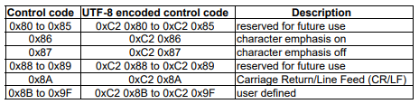

Table Cca: Single byte control codes

For two-byte character tables, the codes in the range 0xE080 to 0xE09F (which are within the private use area of ISO/IEC 1-646 [52]) are assigned to control functions as shown in the table.

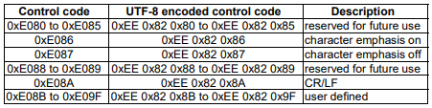

Table Ccb: two-byte control codes

### Selection of character table

Text fields can optionally start with non-spacing, non-displayed data which specifies the alternative character table to be used for the remainder of the text item.

If the first byte of the text field has a value in the range 0x20 to 0xFF then this and all subsequent bytes in the text item are coded using the default character coding table (table 00 - Latin alphabet) of the table Cca.

The selection of the character table is indicated in table Ccc.

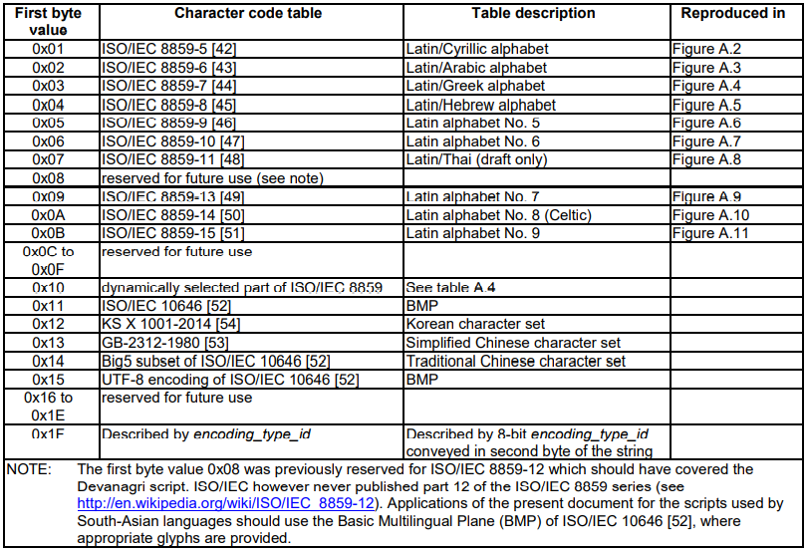

Table Ccc: Character coding tables